AXIOM NEW DEVELOPMENT

Technology:

1. Angular JS with MVC architecture
2. SQL server

Above are the main technology we are using for development to achieve long term benefit in new technology because it is owned by google.

We consider the new application is completely separate and not accessible by any other application of client. Please confirm.

Question/Consideration:

1. We have removed membership related tables and migrate data into one of the table which is created for new application.

UserMaster – This table will be updated as per need for match up the functionality.

We use login user from this table only.

1. We have created RoleMaster table for dynamic role purpose.
2. Rights will be also dynamic
3. We have added CreatedBy, CreatedDate, UpdatedBy, UpdatedDate in almost every table till date we have workout. Of course this will be apply to rest of the tables we will work on.
4. We are going to make new tables for Order creation. You can check in DB…..

OrderDetail, OrderBilling, OrderCase, OrderPatient

We have devided Orders table in above tables (upto step 4)

We are not using RqstOrd any more.

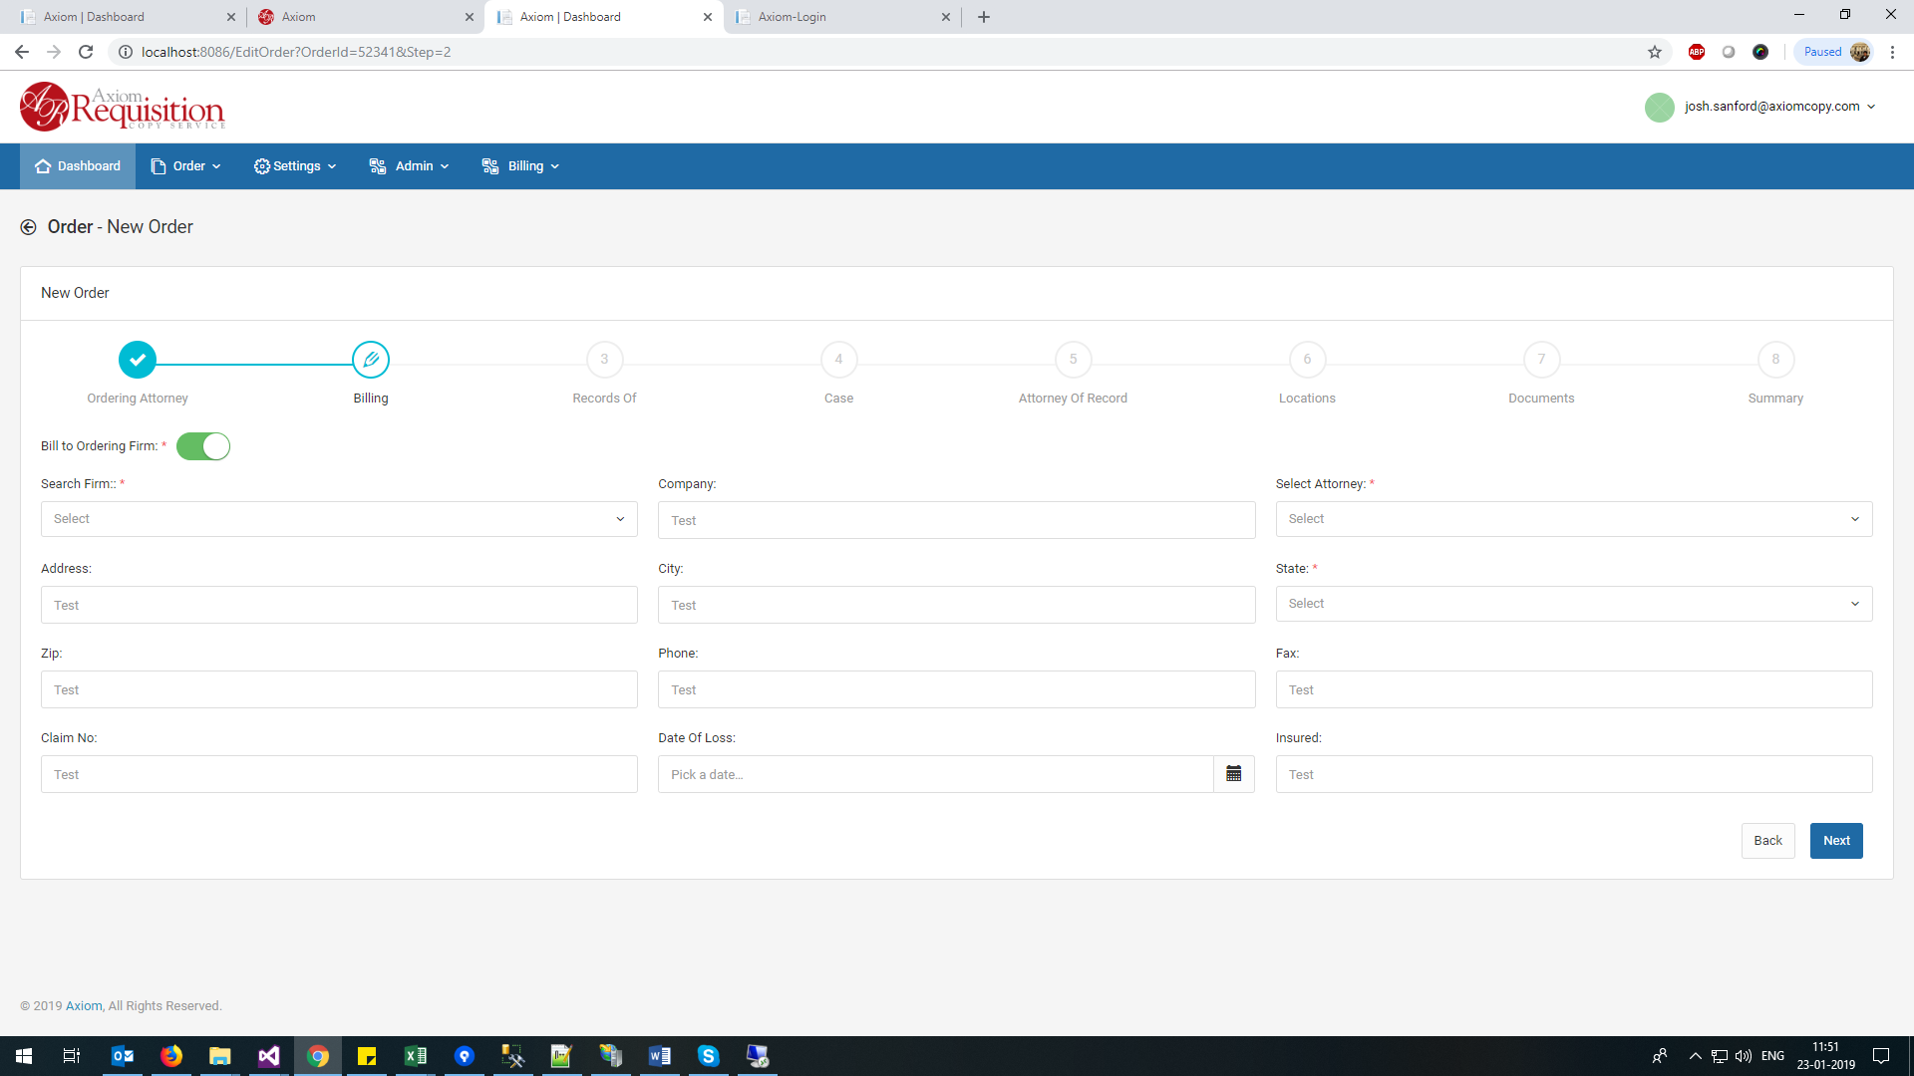

Please visit website and confirm below.

Do we need to save Company, Address, City, State, Zip, Phone, Fax etc? This fields are saved in rqstOrd but not in Orders.

If Company, Address, City, State, Zip, Phone, Fax fields are auto populated as per current system we don’t need to save and make it disabled. What is feedback?

We have noted, rqstAtty table is added with newly added data but OrderId = 0 even if new order is saved in Orders table. Why?

This is not true for rqstPart, in this table OrderId = 0 initially but when final Submit button click, this is updating OrderId = newly generated ID.

Please refer,

Step 1 = OrderDetail,

Step2= OrderBilling,

Step 3 = OrderPatient,

Step 4= Ordercase

Add Attorney Step:

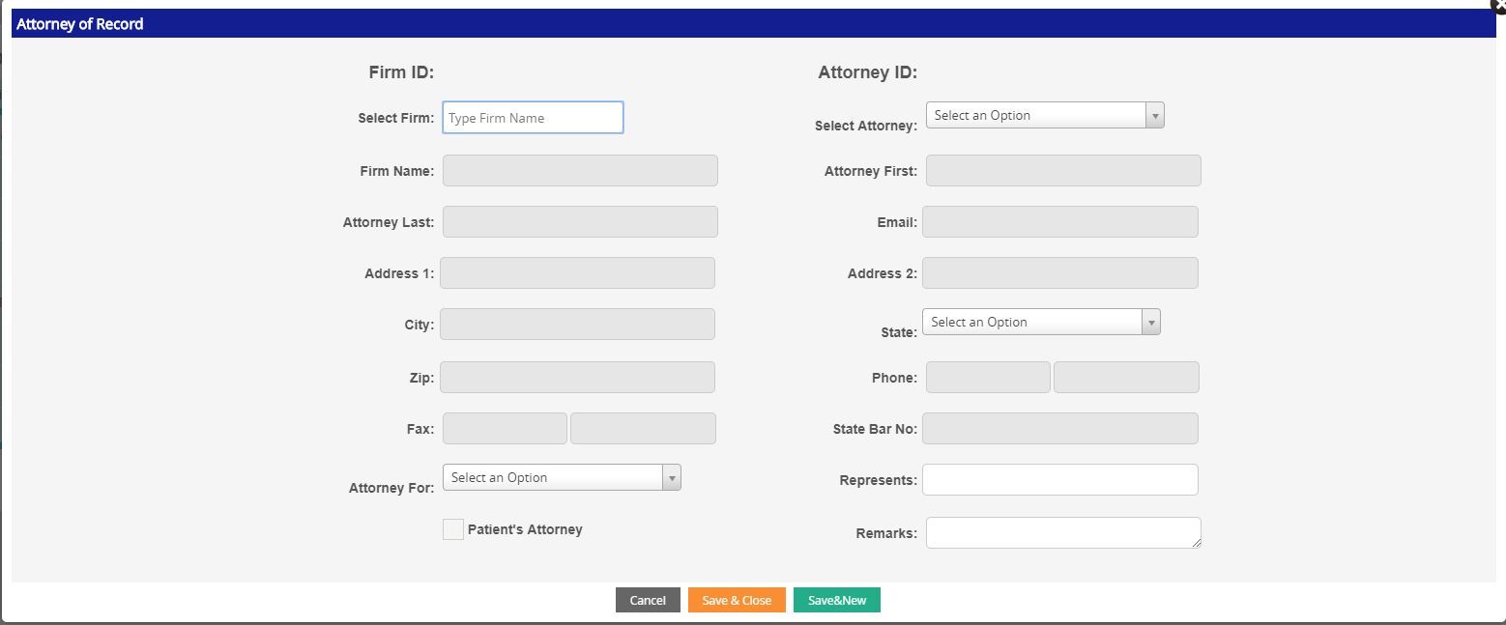

Why we are saving all these disabled fields in DB? Is there any purpose behind this. Let us know so we can know for further DB table design.

Please note, there will be no facility to add Firm or Attorney Record here in above page because I have found that it is not added in “Firms” or “Attorney” table so it is not giving any impact in full system. RqstAtty is a table which basically save the Text of FirmName, attory Name etc. which actually should save ID of Firm and Attorney. So any firm or atty record saved here is not available next time in system. This is not relational database concept.

Please note, there will be no single line of Linq Statement we are planning in new application. For any small DB related functionality Store procedures and functions will be written.

What is the purpose of RqstAtty and OppAtty table?

I need to understand how exactly they place the order and they use the system in admin etc. (video recording)

Do we need LOG page?